**Practical no 2**

**AIM:** Write a program to implement the operation can receive request and will return a response in two ways. a) One - Way operation b) Request –Response

**A)One-Way**

**1. WebForm.aspx file**

|  |
| --- |
| <%@ Page Language="C#" AutoEventWireup="true" CodeBehind="WebForm1.aspx.cs" Inherits="prac2a.WebForm1" %>  <!DOCTYPE html>  <html xmlns="http://www.w3.org/1999/xhtml">  <head runat="server">  <title></title>  </head>  <body>  <form id="form1" runat="server">  <div>  <asp:Button ID="Button1" runat="server" onclick="Button1_Click" Text="Button" />  <br />  <asp:Label ID="lblPagedate" runat="server"> </asp:Label>  <br />  <br />  <asp:Label ID="lblServicedate" runat="server"> </asp:Label>  </div>  </form>  </body>  </html> |

**2. WebForm.aspx.cs file**

|  |
| --- |
| using System;  using System.Collections.Generic;  using System.Linq;  using System.Web;  using System.Web.UI;  using System.Web.UI.WebControls;  namespace prac2a  {  public partial class WebForm1 : System.Web.UI.Page  {  protected void Page_Load(object sender, EventArgs e)  {  }  protected void Button1_Click(object sender, EventArgs e)  {  //Time show before the service is calling  lblPagedate.Text = "on the load time the time is " + DateTime.Now.ToString();  ServiceReference1.Service1Client sc = new ServiceReference1.Service1Client();  sc.OneWayMessage();  //after service is calling that time show  lblServicedate.Text = "After Calling the service the time is " + DateTime.Now.ToString();  }  }  } |

**3. IService.cs:-**

|  |
| --- |
| using System;  using System.Collections.Generic;  using System.Linq;  using System.Runtime.Serialization;  using System.ServiceModel;  using System.ServiceModel.Web;  using System.Text;  namespace prac2a  {  [ServiceContract]  public interface IService1  {  [OperationContract(IsOneWay = true)]  void OneWayMessage();  }  } |

**4. Service1.svc.cs**

|  |
| --- |
| using System;  using System.Collections.Generic;  using System.Linq;  using System.Runtime.Serialization;  using System.ServiceModel;  using System.ServiceModel.Web;  using System.Text;  using System.Threading;  namespace prac2a  {  public class Service1 : IService1  {  public void OneWayMessage()  {  Thread.Sleep(2000);  }  }} |

**Output:-**

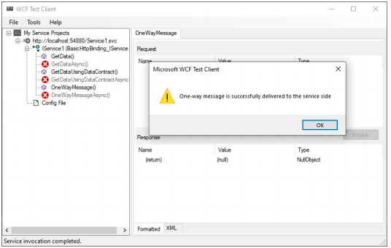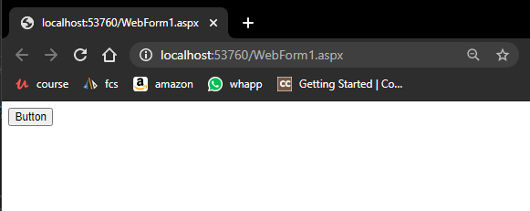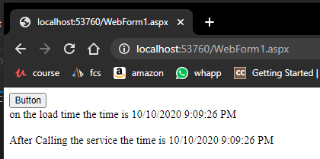

**B) Request –Response**

**1. WebForm.aspx file**

|  |
| --- |
| <%@ Page Language="C#" AutoEventWireup="true" CodeBehind="WebForm1.aspx.cs" Inherits="WcfService2.WebForm1" %>  <!DOCTYPE html>  <html xmlns="http://www.w3.org/1999/xhtml">  <head runat="server">  <title></title>  </head>  <body>  <form id="form1" runat="server">  <div>  <asp:Button ID="Button1" runat="server" onclick="Button1_Click" Text="Button" />  <br />  <asp:Label ID="lblPagedate" runat="server"></asp:Label>  <br />  <br />  <asp:Label ID="lblServicedate" runat="server"></asp:Label>    </div>  </form>  </body>  </html> |

**2. WebForm.aspx.cs file**

|  |
| --- |
| using System;  using System.Collections.Generic;  using System.Linq;  using System.Web;  using System.Web.UI;  using System.Web.UI.WebControls;  namespace WcfService2  {  public partial class WebForm1 : System.Web.UI.Page  {  protected void Page_Load(object sender, EventArgs e)  {  }  protected void Button1_Click(object sender, EventArgs e)  {  lblPagedate.Text = "Page date is " + DateTime.Now.ToString();  ServiceReference1.Service1Client sc = new ServiceReference1.Service1Client();  lblServicedate.Text = sc.RequestReplyPattern();  }  }  } |

**3. IService.cs:-**

|  |
| --- |
| using System;  using System.Collections.Generic;  using System.Linq;  using System.Runtime.Serialization;  using System.ServiceModel;  using System.ServiceModel.Web;  using System.Text;  namespace WcfService2  {  [ServiceContract]  public interface IService1  {  [OperationContract(IsOneWay = false)]  //declare the method which return type is string  string RequestReplyPattern();  }  } |

**4. Service1.svc.cs**

|  |
| --- |
| using System;  using System.Collections.Generic;  using System.Linq;  using System.Runtime.Serialization;  using System.ServiceModel;  using System.ServiceModel.Web;  using System.Text;  using System.Threading;  namespace WcfService2  {  public class Service1 : IService1  {  public string RequestReplyPattern()  {  Thread.Sleep(2000);  return "current time of Service is" + DateTime.Now.ToString();  }  }  } |

**Output:-**

